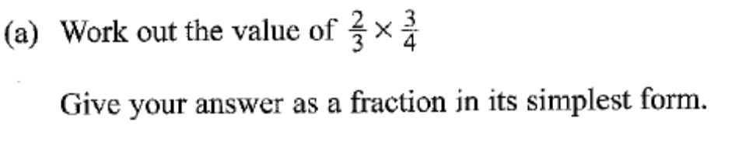
Correct/incorrect. How do you know?
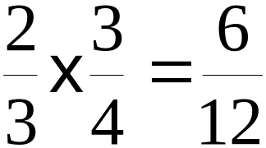(2 marks)

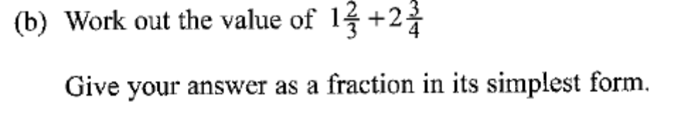
Correct/incorrect. How do you know?
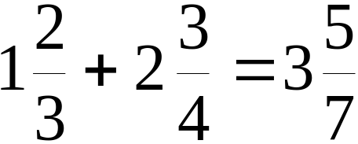(3 marks)

